Name : Revati Bondre

Batch: B22

Date: 01/12/2022

Assignment :  
learn git push and pull commands try them on your own repository.

git push command output:

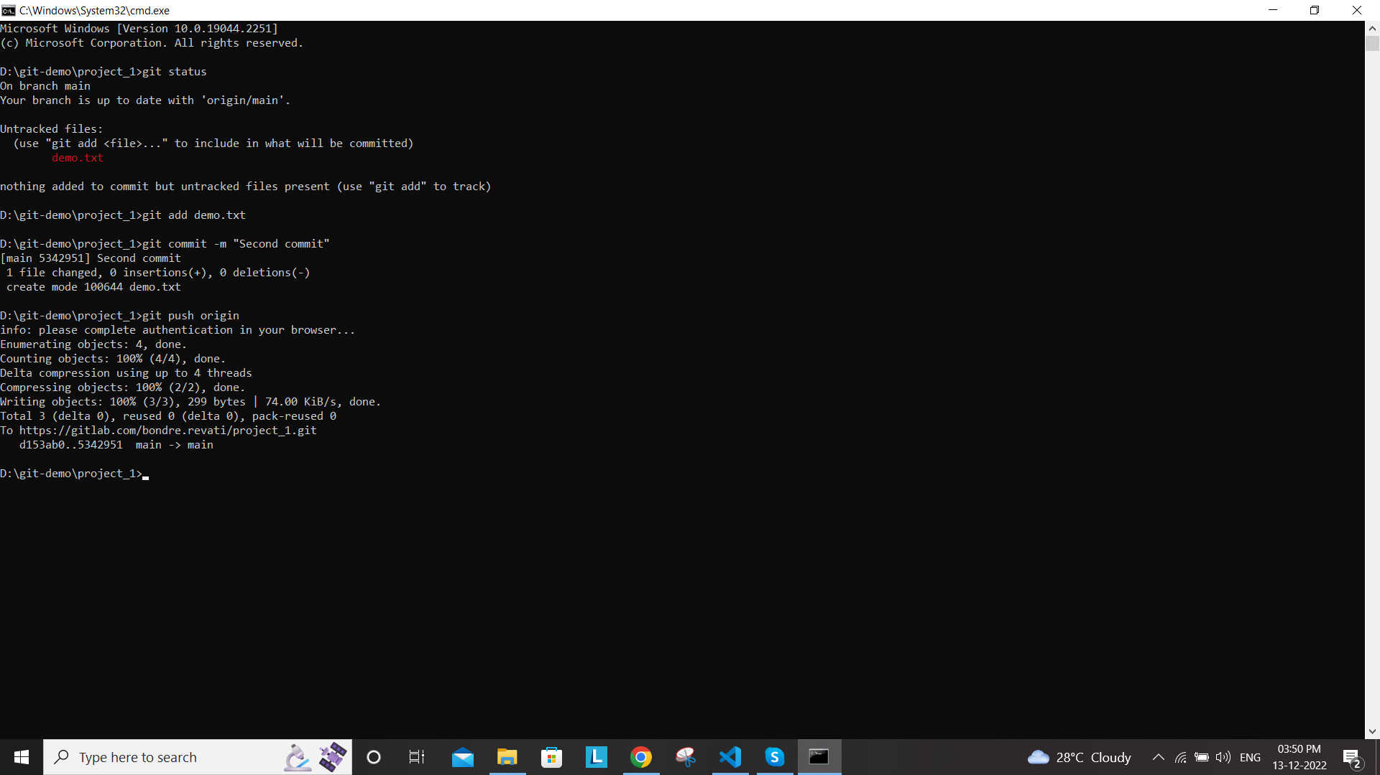

git pull command output:

